Tutorial-6

Modules name:amazon
Test Case ID:shitaljogi_2112
Environment Information:os:macos(Sequoria 15.5)system : laptop(macbook air)webpage URL:https://www.amazon.in/ap/cvf/verify

Screenshort:
Scenario 1:

Demo login page:open amazon website
Test Steps:1a
1.open the amazon website
2.click the login page
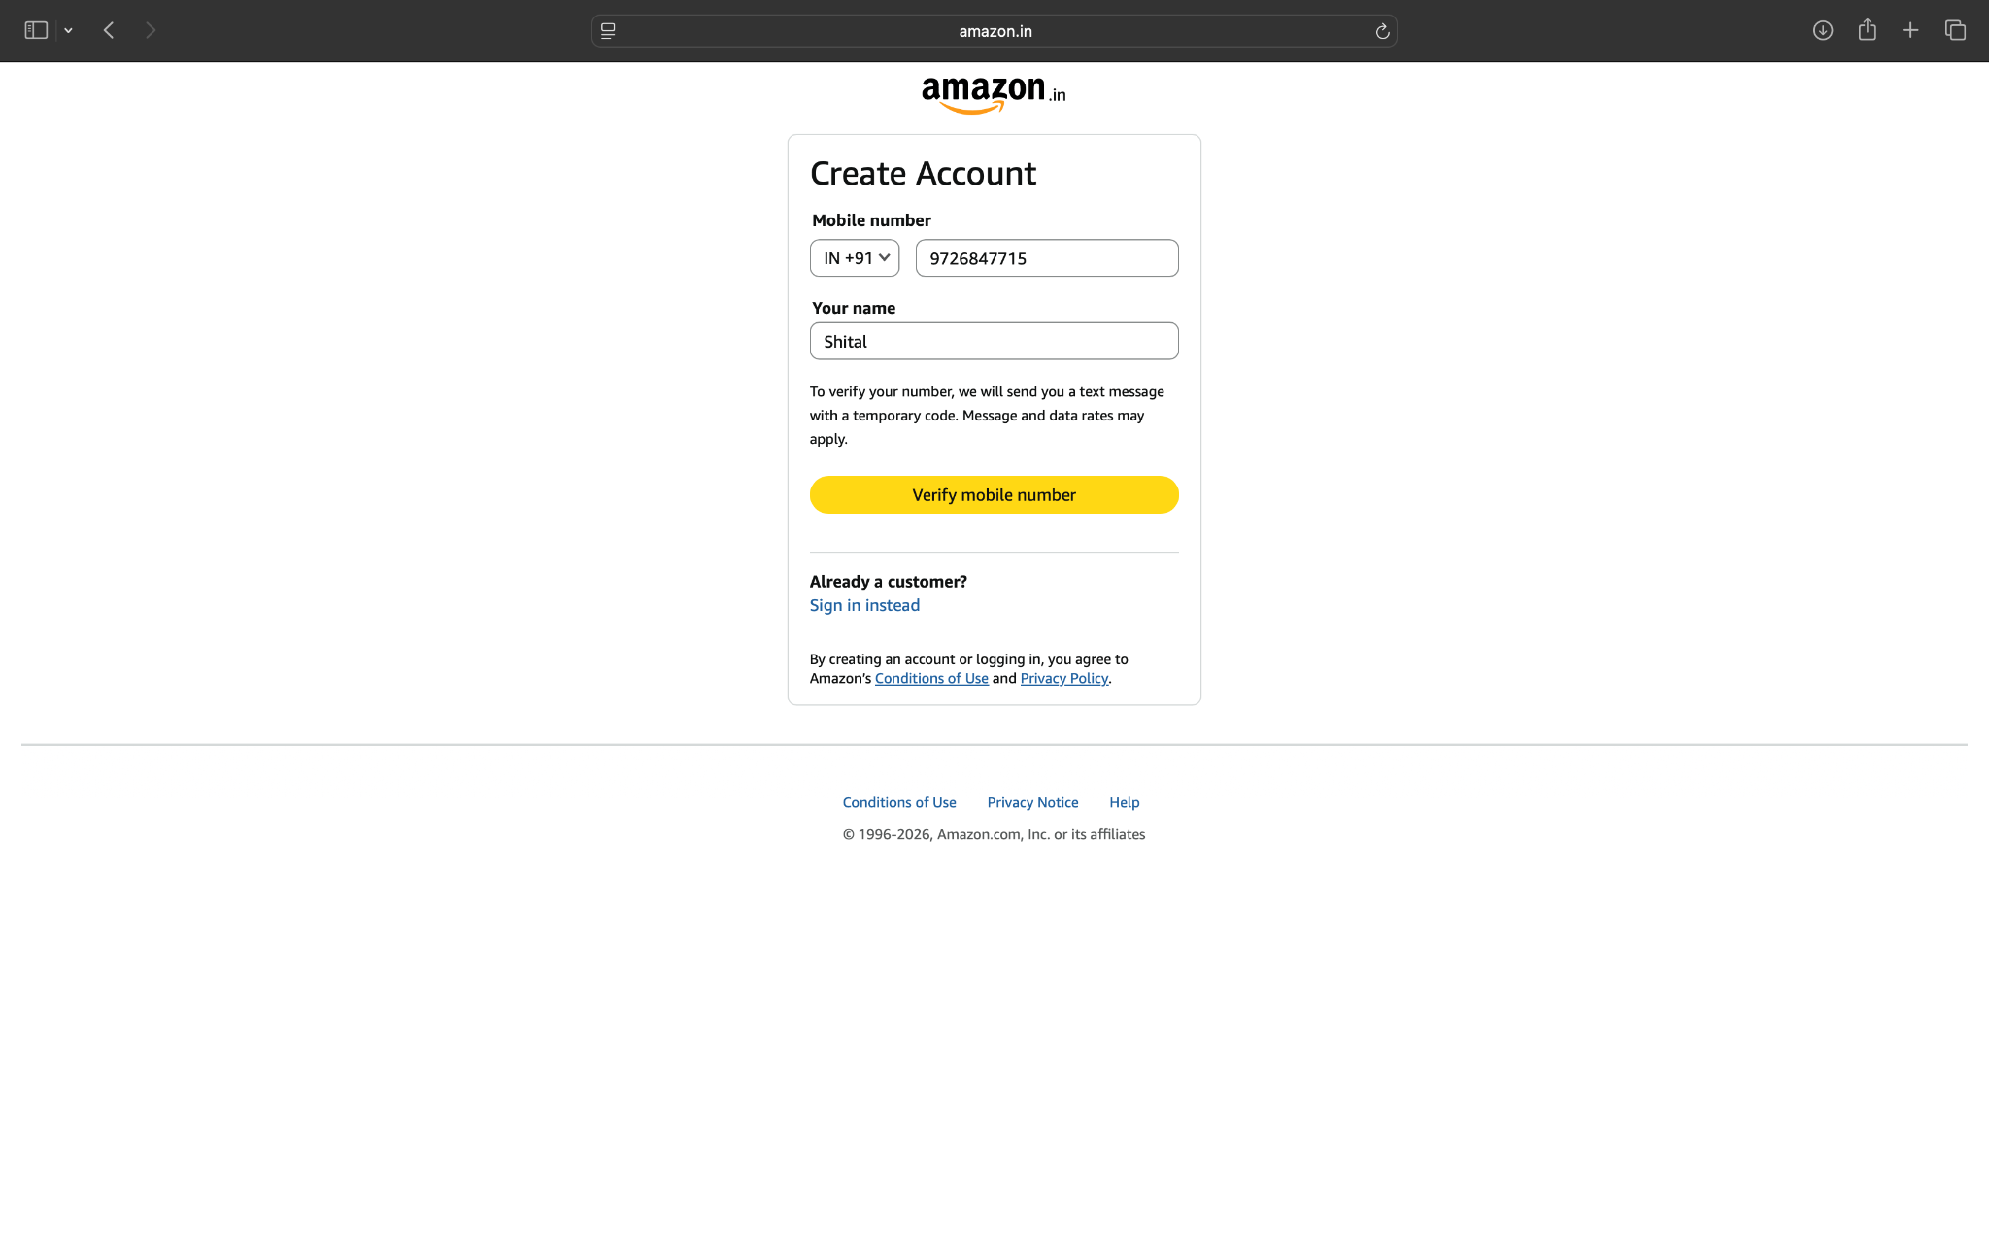

Screenshort:
Scenario 1:

Demo login page:open amazon website and search the product
Test Steps:1b
1.open the amazon website
2.click the login page
3.amazon open and search the product name

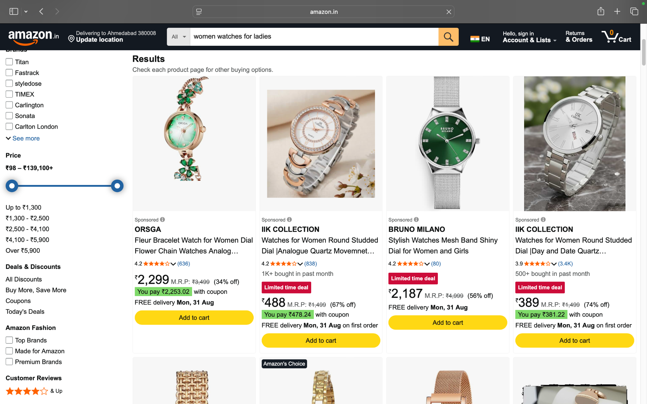

Screenshort:
Scenario 1:

Demo login page:open amazon website and search the product and select
Test Steps:1c

1.open the amazon website
2.click the login page
3.amazon open and search the product name
4.select the product

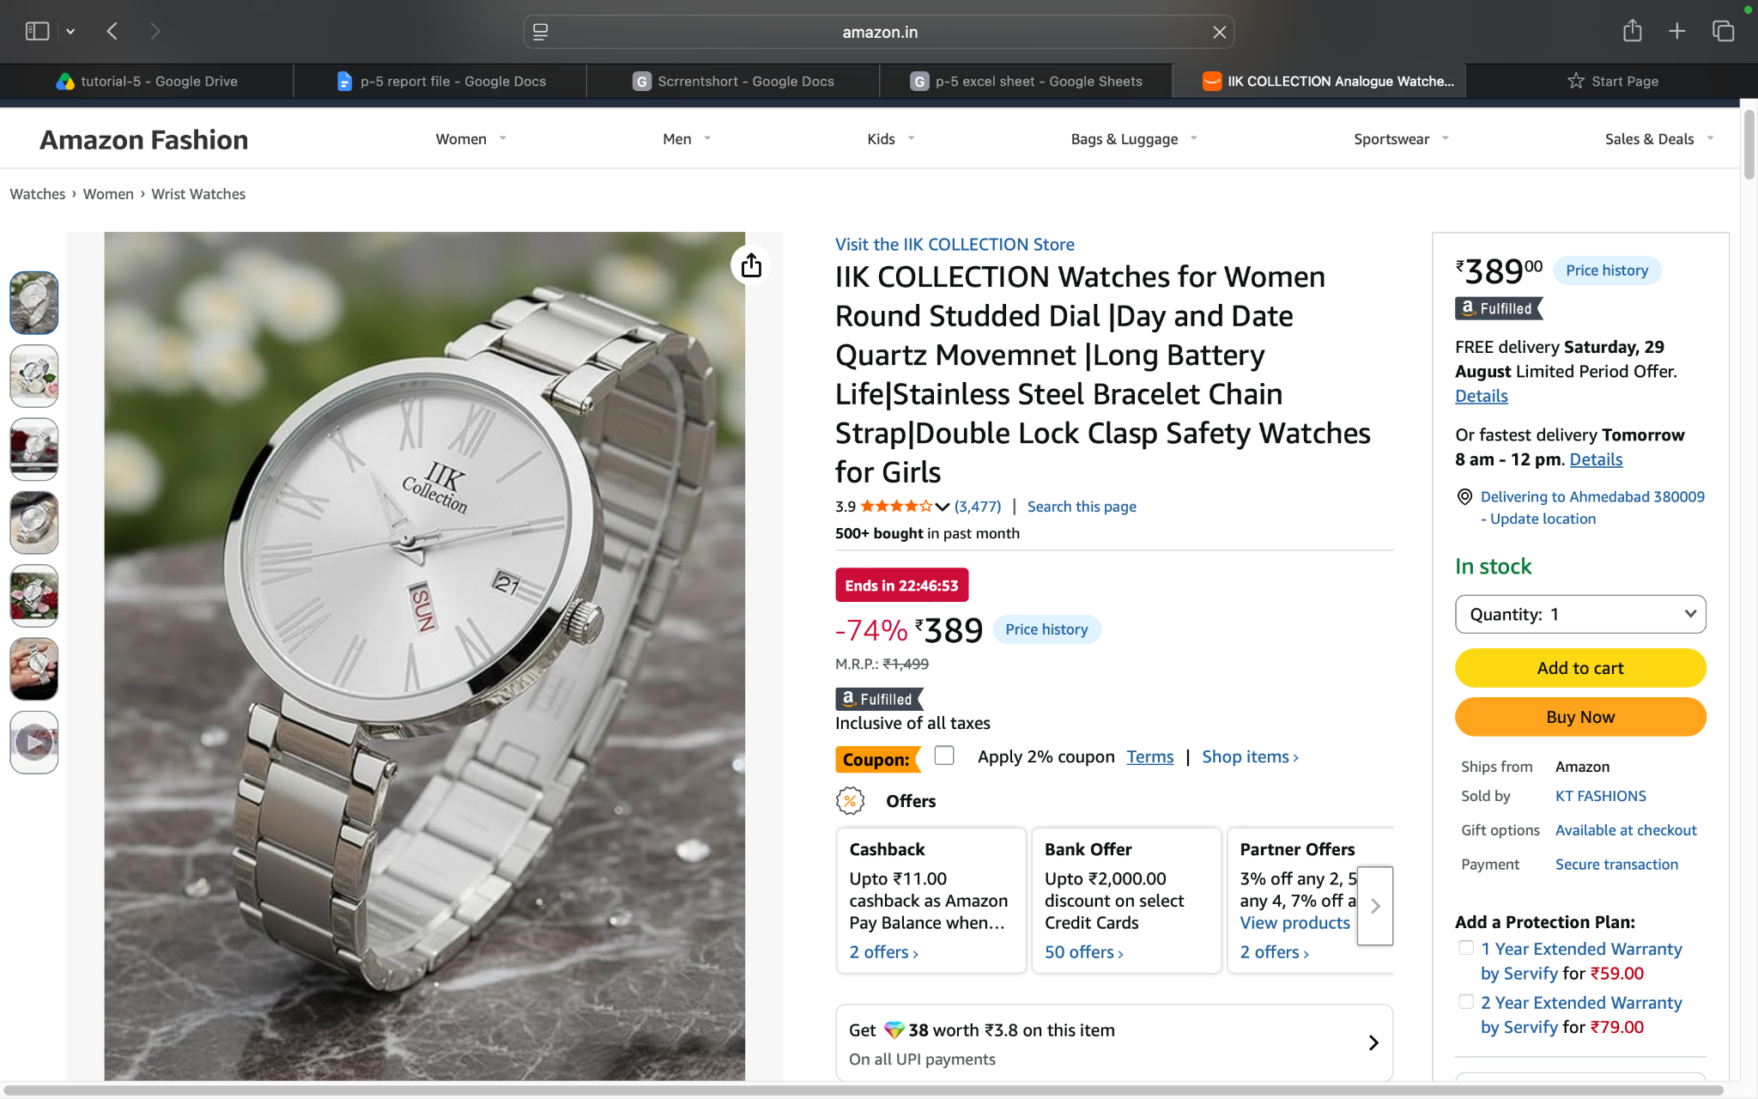

Screenshort:
Scenario 1:

Demo login page:open amazon website and select the product and verify product details
Test Steps:1d
1.open the amazon website
2.click the login page
3.amazon open and search the product name
4.select the product
5.verify the product details

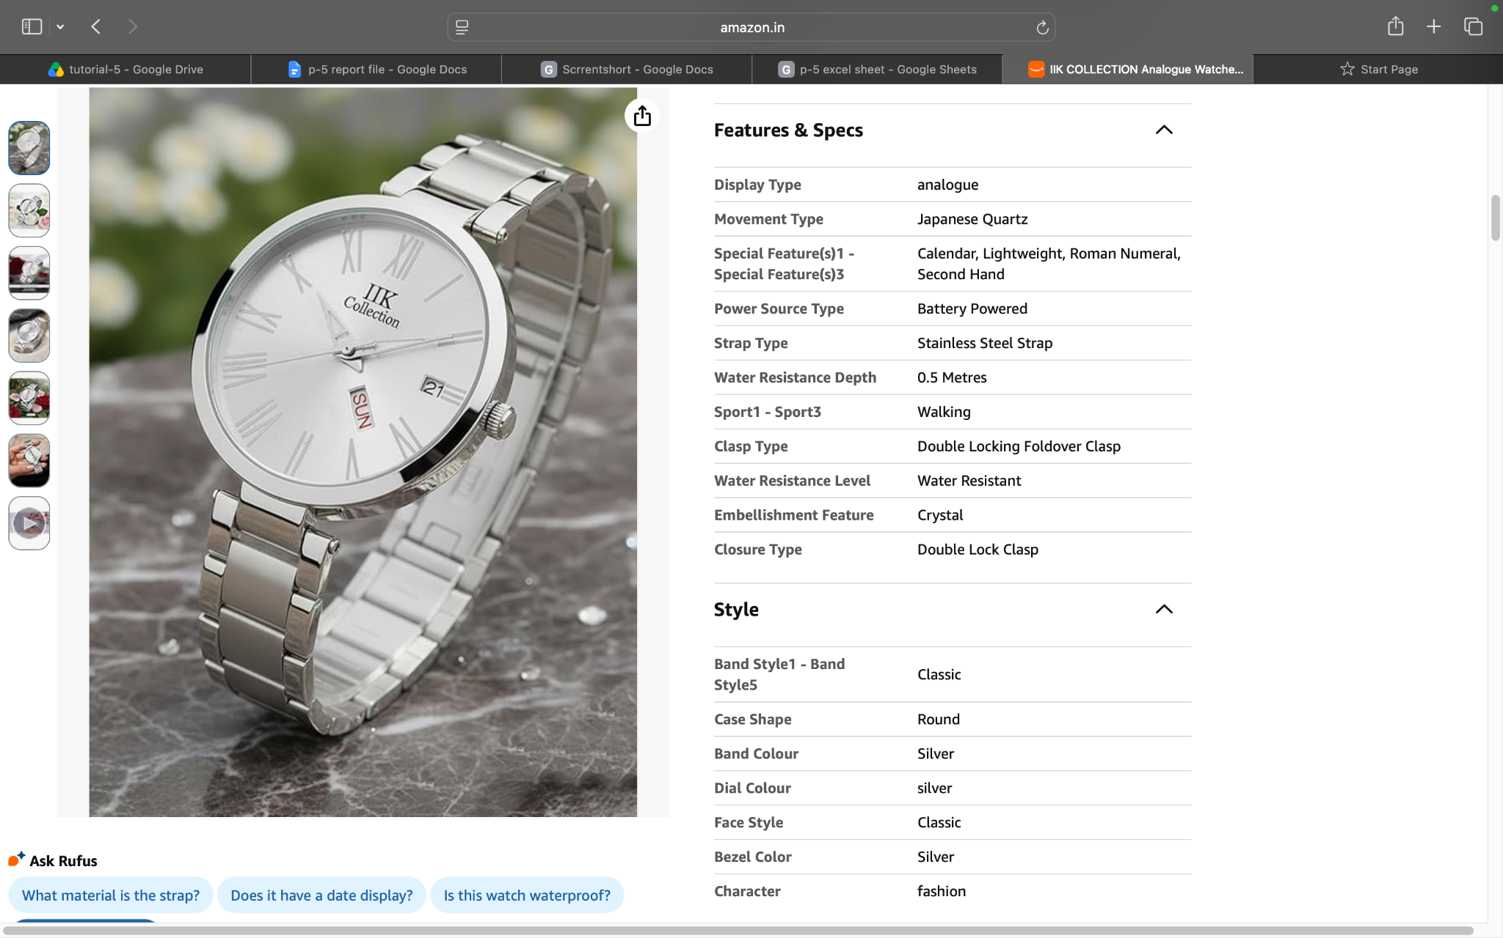

Screenshort:
Scenario 1:

Demo login page:open amazon website and select the product and verify product details to add to cart
Test Steps:1e
1.open the amazon website
2.click the login page
3.amazon open and search the product name
4.select the product
5.verify the product details
6.product added to cart

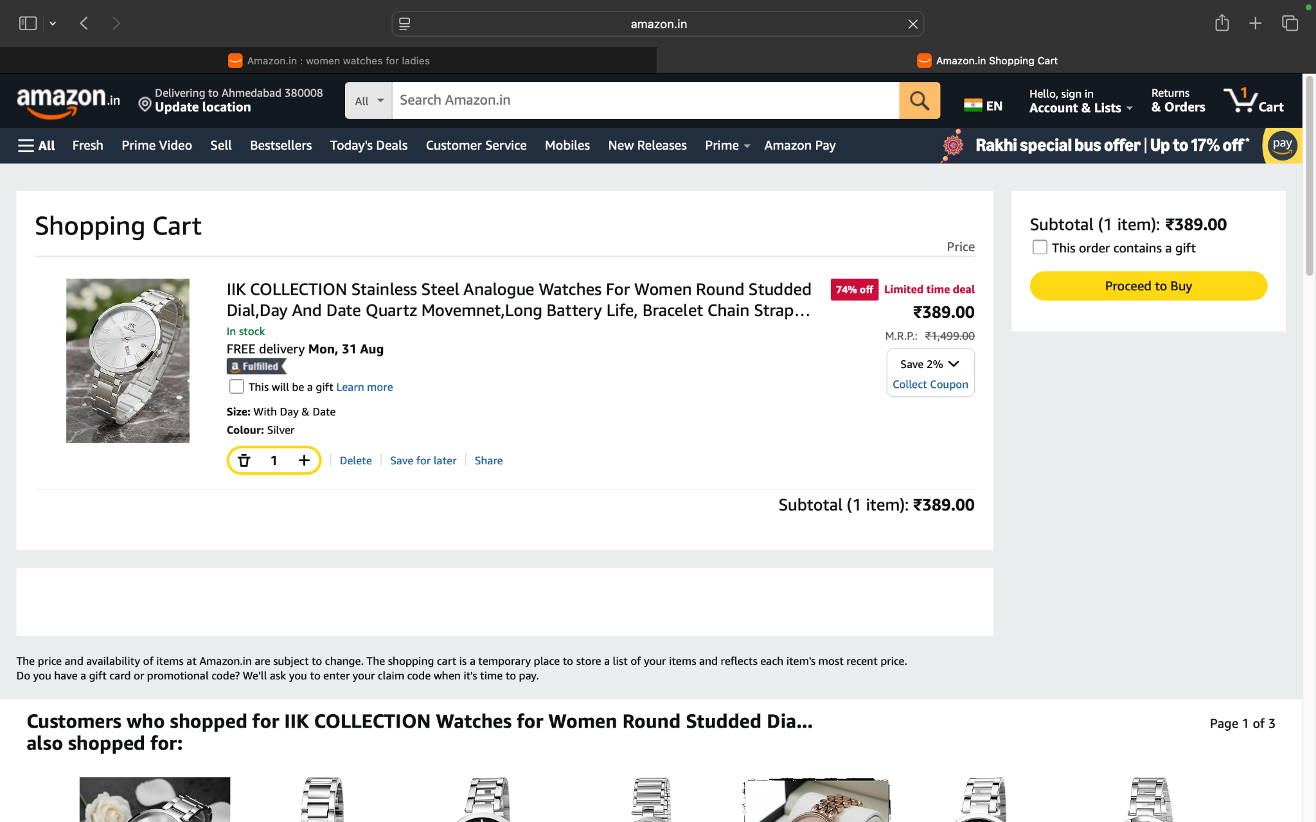

Screenshort:
Scenario 1:

Demo login page:open amazon website and select the product and verify product details to add to cart view
Test Steps:1f
1.open the amazon website
2.click the login page
3.amazon open and search the product name
4.select the product
5.verify the product details
6.view the product added to cart

Screenshort:
Scenario 1:

Demo login page:open amazon website and select the product and verify product details to add to cart view change to qulitity
Test Steps:1g
1.open the amazon website
2.click the login page
3.amazon open and search the product name
4.select the product
5.verify the product details
6.view the product added to cart
7.change the quality

Screenshort:
Scenario 1:

Demo login page:open amazon website and select the product and verify product details to add to cart view and proceed to buy product
Test Steps:1g
1.open the amazon website
2.click the login page
3.amazon open and search the product name
4.select the product
5.verify the product details
6.view the product added to cart
7.procced to buy product

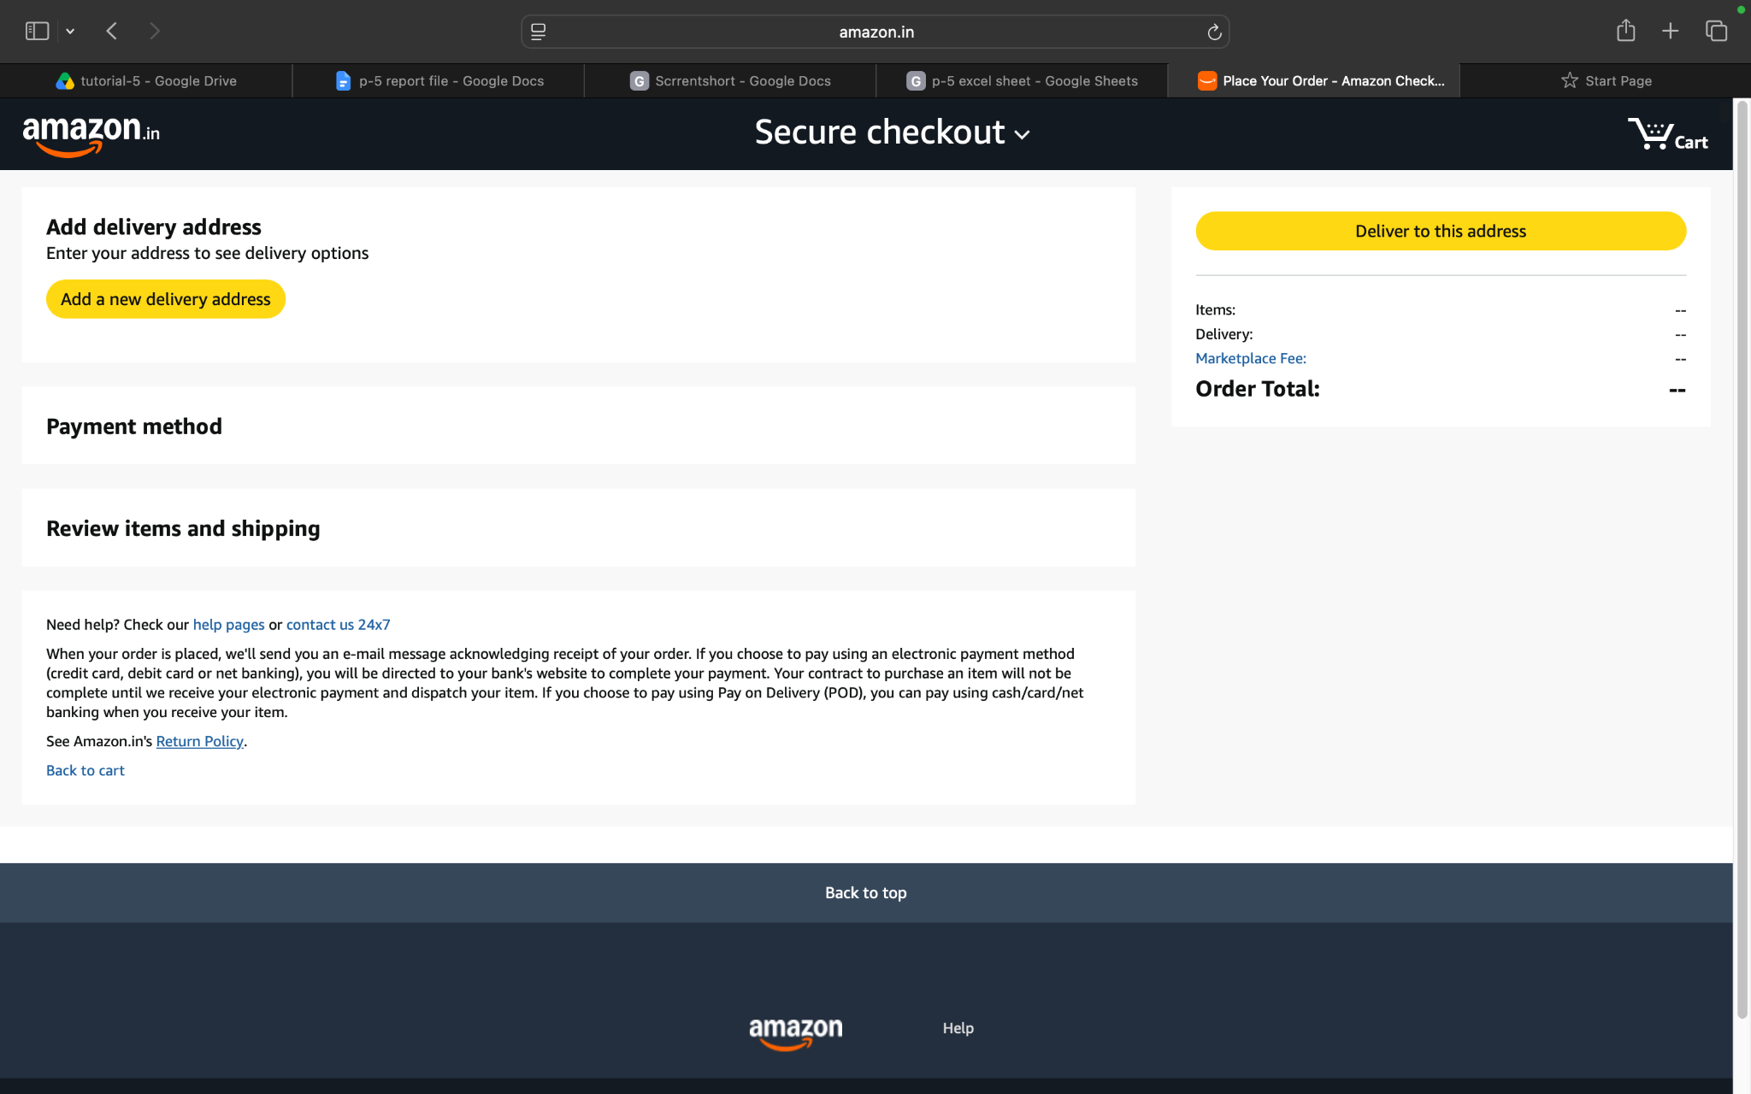

Screenshort:
Scenario 2:

Demo login page:open amazon website and verify to customer details
Test Steps:2a
1.open the amazon website
2.click the login page
3.amazon open and search the product name
4.select the product
5.verify the product details
6.view the product added to cart
7.procced to buy product
8.verify the customer details

Screenshort:
Scenario 2:

Demo login page:open amazon website and select the delivery option
Test Steps:2b
1.open the amazon website
2.click the login page
3.amazon open and search the product name
4.select the product
5.verify the product details
6.view the product added to cart
7.procced to buy product
8.verify the customer details
9.select the delivery option

Screenshort:
Scenario 2:

Demo login page:open amazon website and verify the order summary
Test Steps:2c
1.open the amazon website
2.click the login page
3.amazon open and search the product name
4.select the product
5.verify the product details
6.view the product added to cart
7.procced to buy product
8.verify the customer details
9.select the order summary

Screenshort:
Scenario 2:

Demo login page:open amazon website and verify the payment
Test Steps:2d
1.open the amazon website
2.click the login page
3.amazon open and search the product name
4.select the product
5.verify the product details
6.view the product added to cart
7.procced to buy product
8.verify the customer details
9.select the order payment

